Project Budget: 2023 Good Measure Ice Cream

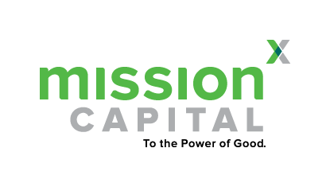
Project Summary: To advance the important work of the local ice cream trucks in our South Austin neighborhoods, the ice cream truck coalition is conducting extensive research and evaluation on current business models. This project will involve the collection of community feedback, business models that prioritize the taste buds of all residents…

Portfolio Component | Estimated Expense | Actual Expense
Community Reviewer Stipend Fund – This will help compensate neighborhood residents on experience with current ice cream truck schedule/ice cream options | 2000
Community Ice Cream Tasting Event | 6000
Total

